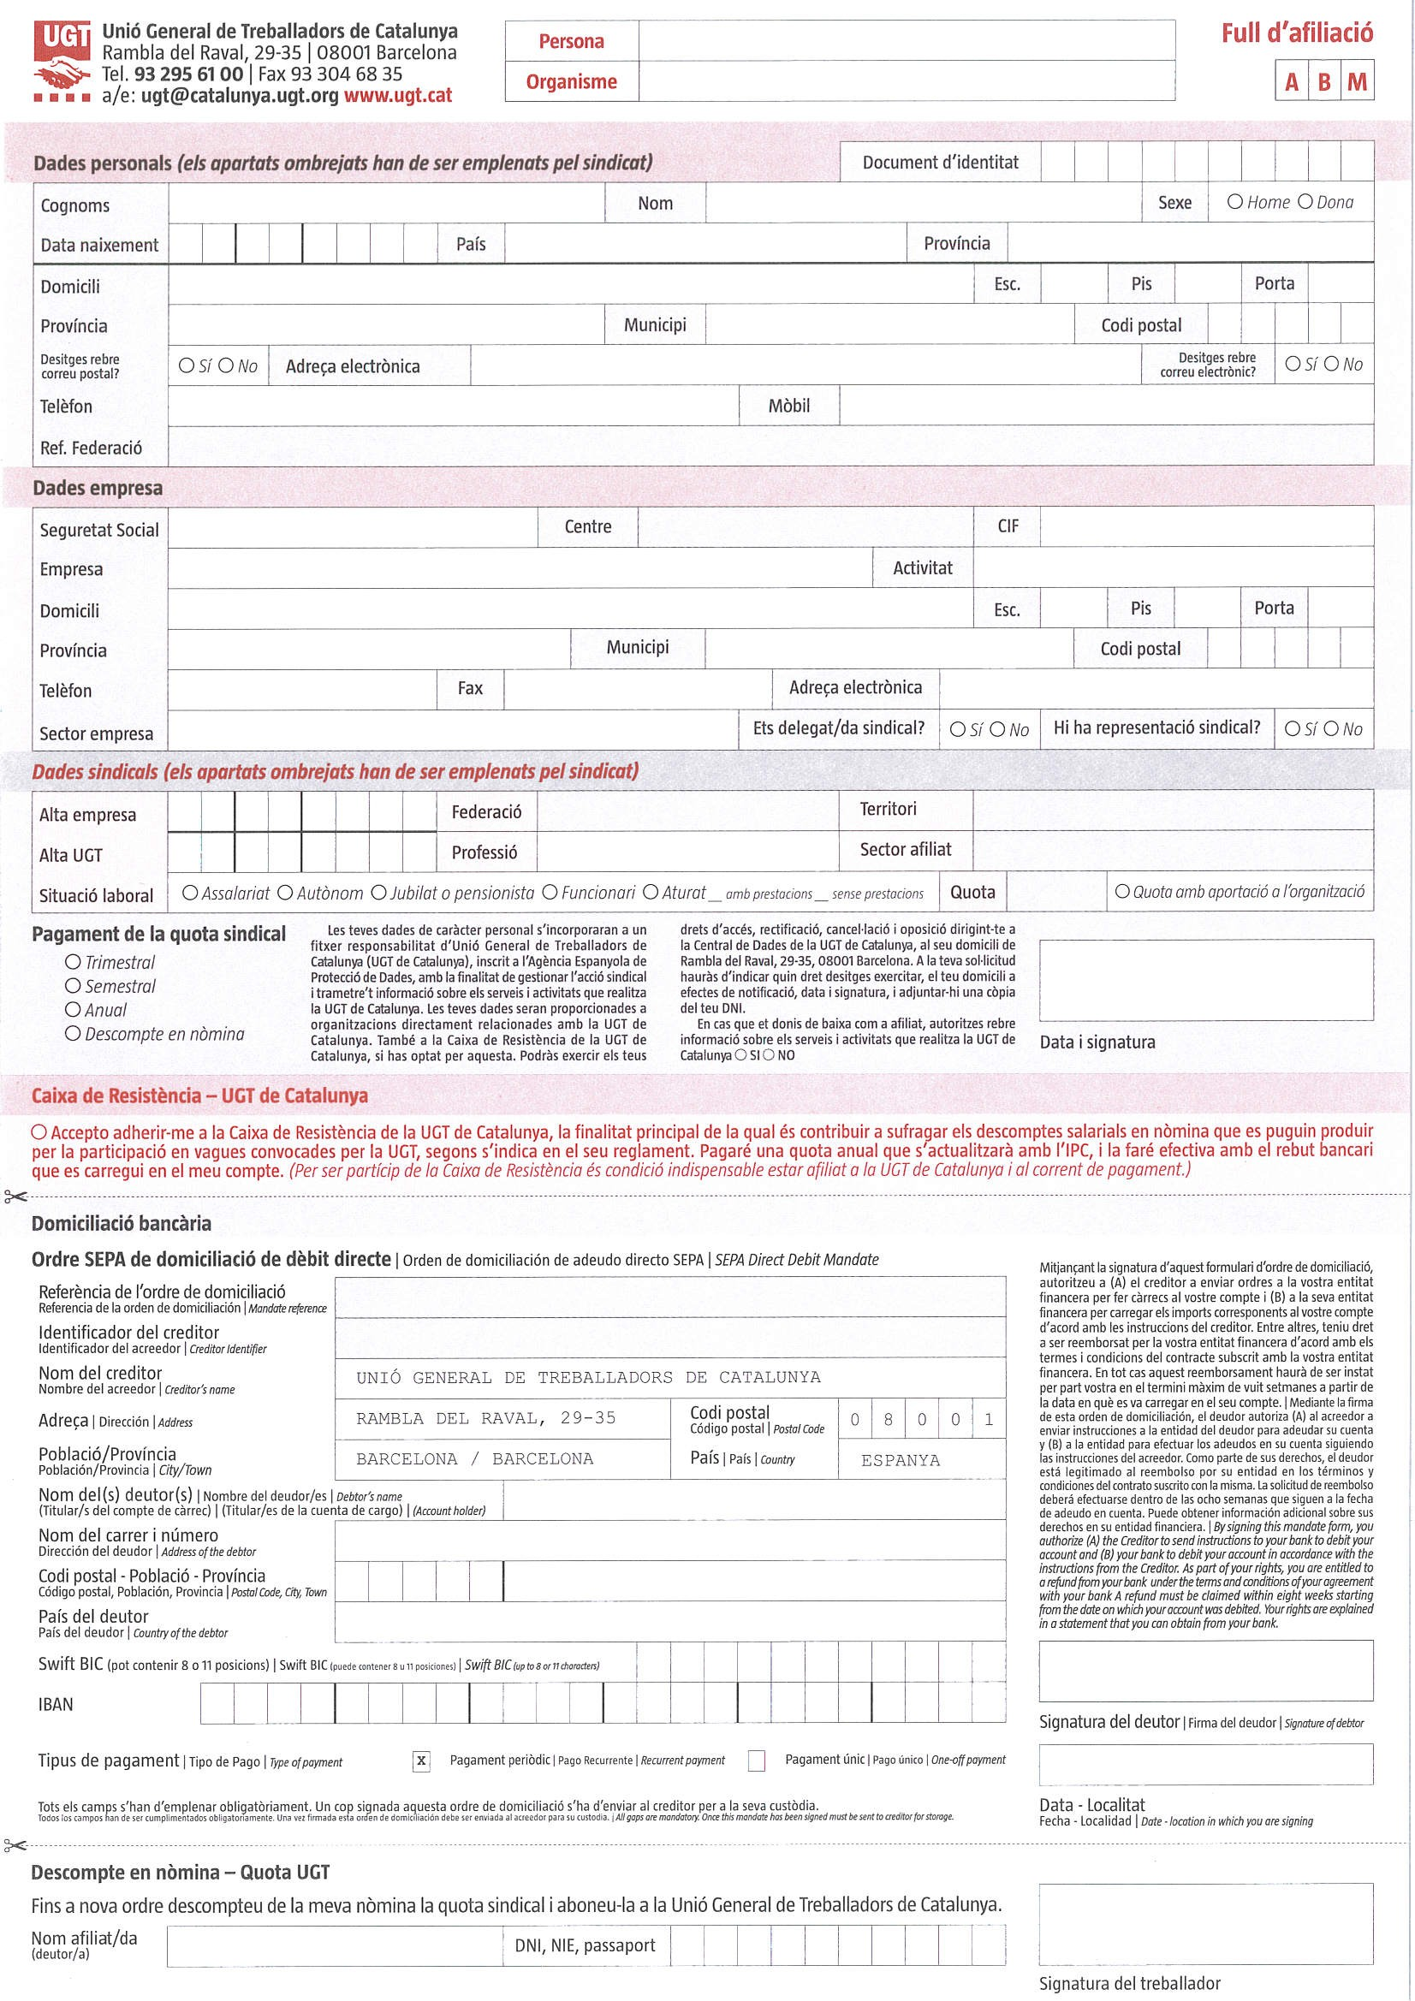

SMC-UGT

GIRONES

SMC-UGT